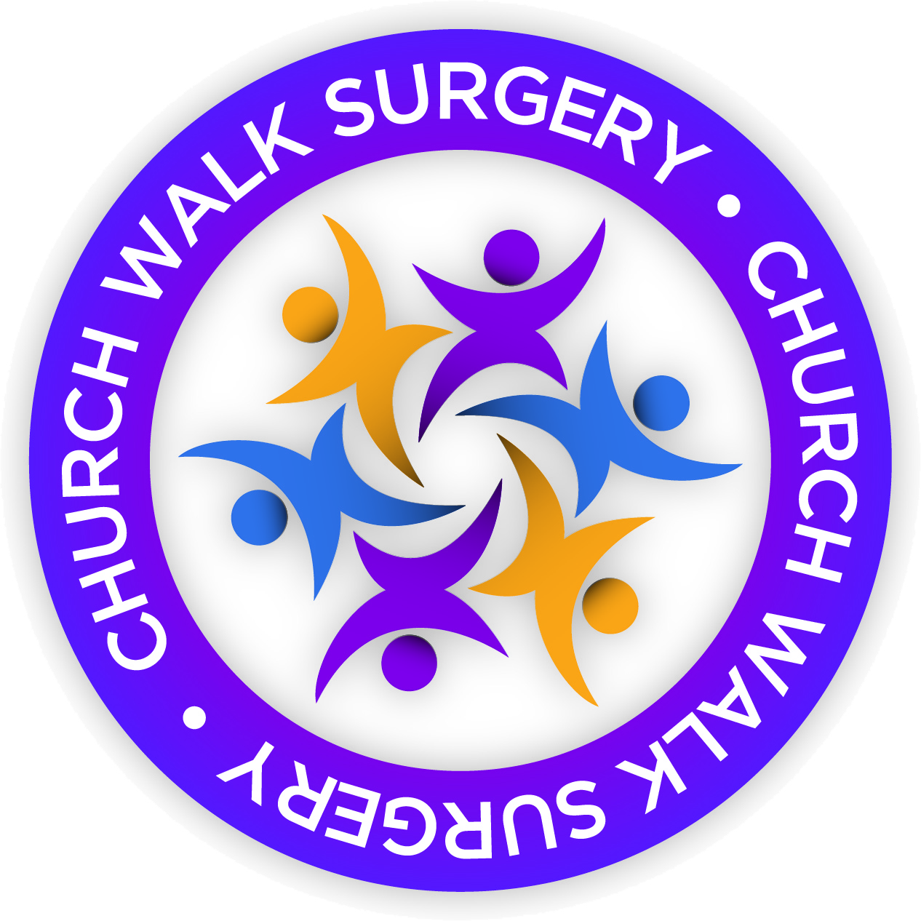
CONSENT TO SHARE MY
MEDICAL INFORMATION

I
Of
D.O.B.:
Telephone:
give my consent for:

Name | Relationship to Patient | Contact Details

To access/discuss:

Appointments Medication Results Recent consultations

Letter from other care providers (eg hospitals)

OR:

All of the above

I understand that this consent will remain in place, until I give written notification otherwise.

Signed:
Date:

Please return this form to Church Walk Surgery

